Project on

**Water level indicator with Alarm**

Prepared by:

**Md. Shakibul Alam (20301286)**

Course Code: CSE260

Course Title: Digital Logic Design

Department : CSE

BRAC University



**Introduction:**

This project is about designing a water level indicator system with an alarm. Every building in our country has water tanks. People need to turn on water motors to fill up these tanks, but most times they do not know the level of water in the tanks. A water level indicator is a system that rings an alarm to indicate whether a body of a tank has a high or low water level. The water level indicator employs a simple mechanism to indicate the water level in an overhead tank or any other water container. The purpose of a water level indicator is to gauge water levels in a water tank and alert people to turn the motor on or off. Whenever a tank gets filled or empty, the alarm rings on particular levels. The alarm also rings if an adequate water supply is not available to fill the tank when the water level is less than 95%. This can remind people to turn on a water pump once levels get too low and refill the water back to the adequate level, or to turn it off once the water level is high. This project is a simulation of a complete water level indicator system that can also be implemented with real components.

As water is a very essential commodity in the lives of humans, the use of the water level indicator system is very important. The main motive of choosing and doing this project based on the water level indicator with an alarm is to save water as much as possible. This system will save water because as we are giving alerts when the water level reaches 95%, people can turn off the motor and prevent overflow of water.

**Proposed Model:**

**Input:**

(1) A=1 if water supply available, A=0 otherwise

(2) B=1 if the water level is less than 10%, B=0 otherwise

(3) C=1 if the water level is more than 95%, C=0 otherwise

(4) D=1 if electricity is available, D=0 otherwise

**Output:**

1. Green Light (G)
2. Red Light (R)
3. Alarm (S)

**Condition:**

1. The RED LIGHT = 1 if electricity is available and (water level is less than 10 or water supply = 0)
2. GREEN LIGHT =1 if electricity is available and water is more than 95%.
3. ALARM = 1 if RED LIGHT =1 or GREEN LIGHT = 1
4. Red light and green light cannot be turned on at the same time. Green-light has greater priority.
5. Inputs B and C cannot be 1 at the same time, as the water level cannot be less than 10% and greater than 95% at the same time, so the outputs for those conditions must be don't care.

**Truth table:**

|  |  |  |  |  |  |  |
| --- | --- | --- | --- | --- | --- | --- |
| **A** | **B** | **C** | **D** | **R** | **G** | **S** |
| 0 | 0 | 0 | 0 | 0 | 0 | 0 |
| 0 | 0 | 0 | 1 | 1 | 0 | 1 |
| 0 | 0 | 1 | 0 | 0 | 0 | 0 |
| 0 | 0 | 1 | 1 | 0 | 1 | 1 |
| 0 | 1 | 0 | 0 | 0 | 0 | 0 |
| 0 | 1 | 0 | 1 | 1 | 0 | 1 |
| 0 | 1 | 1 | 0 | x | x | x |
| 0 | 1 | 1 | 1 | x | x | x |
| 1 | 0 | 0 | 0 | 0 | 0 | 0 |
| 1 | 0 | 0 | 1 | 0 | 0 | 0 |
| 1 | 0 | 1 | 0 | 0 | 0 | 0 |
| 1 | 0 | 1 | 1 | 0 | 1 | 1 |
| 1 | 1 | 0 | 0 | 0 | 0 | 0 |
| 1 | 1 | 0 | 1 | 1 | 0 | 1 |
| 1 | 1 | 1 | 0 | x | x | x |
| 1 | 1 | 1 | 1 | x | x | x |

R= ⅀(1, 5,13) + d(6, 7,14,15)

G= ⅀(3, 11) + d(6, 7,14,15)

S= ⅀(1, 3, 5,11,13) + d(6, 7,14,15)

**K-map:**

For Red light,

R = ⅀ (1,5,13) + d (6,7,14,15)

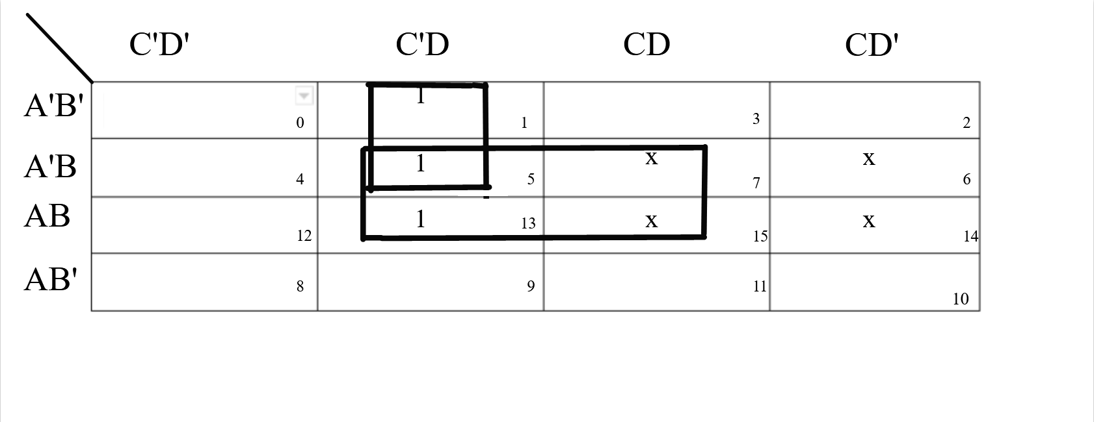

R = A’C’D + BD

For Green light,

G = ⅀ (3,11) + d (6, 7,14,15)

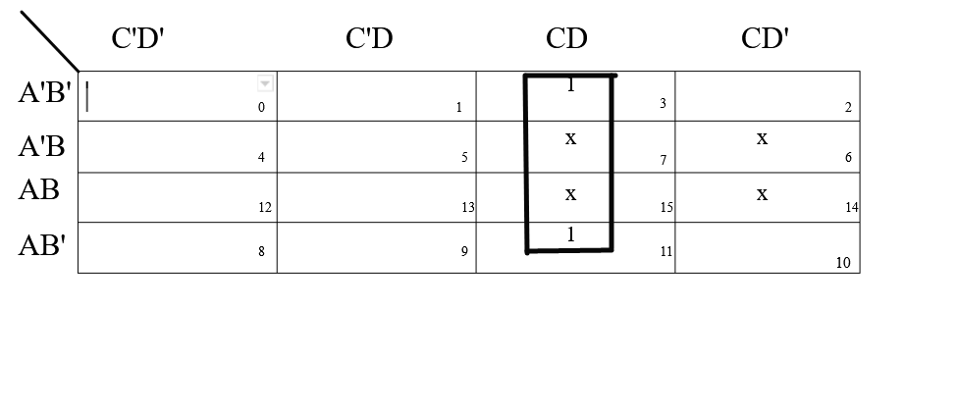G = CD

For Alarm,

S = ⅀ (1, 3, 5, 11, 13) + d (6,7,14,15)

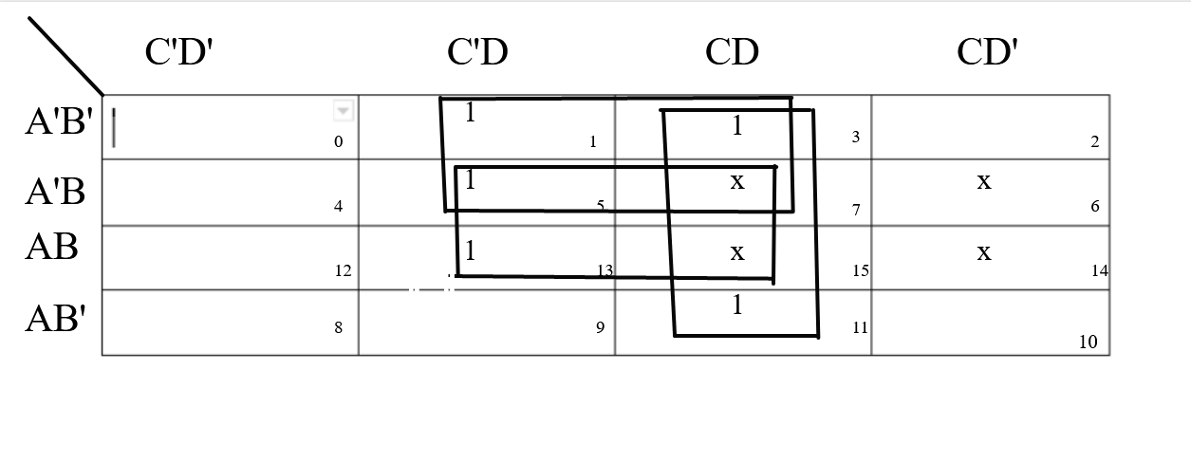

S = A’D + BD + CD

**Experimental setup:**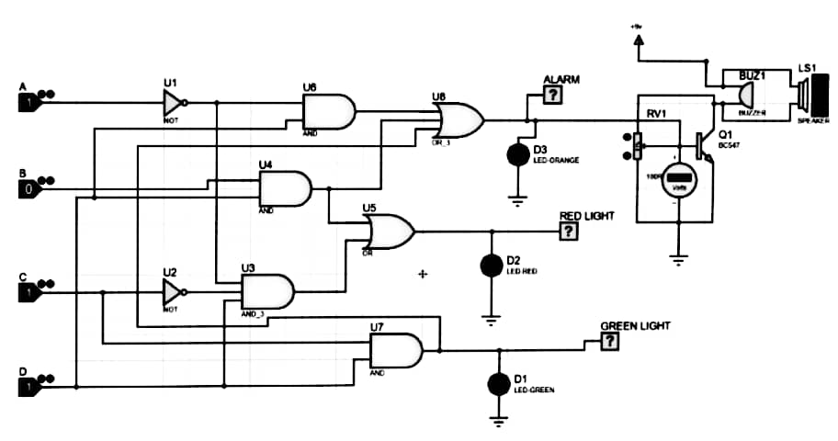

**Conclusion:**

We have conducted this project on proteus simulation software and the required types of equipment we have used are:

* Logicstate
* LogicProbe [Big]
* LED [orange, red,green]
* AND gate
* OR gate
* NOT gate
* Ground
* Power
* Buzzer
* DC Voltmeter
* Speaker
* Potentiometer
* Transistor

Firstly, for our four inputs we have taken four logic states named [A, B, C, D] and each of the logic states indicates meaningful tasks like A indicates water supply, B indicates the water level is less than 10%, C indicates the water level is more than 95%, D indicates electricity. We have completed the table by following the conditions which are based on the scenario. In the table, we have used “Don’t Cares” for the combinations where B=1 and C=1 as water level can’t be less than 10% and greater than 95% at the same time. Then, utilizing SOP minimum terms, we finished the K map. From the K-map we have got three boolean equations and we have drawn the circuit from the three equations. From the design of the water level indicator on the proteus simulation software, we can see that when the water level reaches point B[ water level less than 10%], the circuit with RED LED glows and the buzzer starts beeping. Similarly, when the water level reaches point C [ water level greater than 95%], the GREEN LED glows and a circuit with a buzzer gets completed and the buzzer starts beeping. Finally when there is no water supply and the water level is less than 95%, the RED LED glows and the circuit with the buzzer gets completed and the buzzer starts beeping again.

Problems that arose during the design of this project are:

* We had difficulty designing the sound system because we hadn't previously developed or used any sound system in the proteus simulation software.
* We needed to spend some time learning about some new equipment when creating this project, such as a potentiometer, transistor, and dc voltmeter.
* We needed to make a decision whether to give priority to the red light or the green light. We decided to prioritize the green light, as green light means that the water level is greater than 95%, and our main purpose is to save water.

**Limitations:**

* This system will not work in the absence of electricity.
* As this project is designed on simulation software and we haven’t built the circuit physically, we can’t assure that this project will work perfectly in real-life situations.